# ­ US_003: Automatic Tagging – Upload Collection:

|  |  |
| --- | --- |
| Description | As a customer, I want to login with my credentials so I can upload a new collection at any given time and access it from anywhere in the application. |
| Assigned To | Svetlana Kordumova |
| State | In Design |
| Priority | High |
| Risk | High |

Acceptance Criteria:

|  |  |
| --- | --- |
| Upload Collection Button | Fixed on the left side of the Dashboard |
| Item from the list menu at the upper right side | Expand the menu and it should be the first item. |

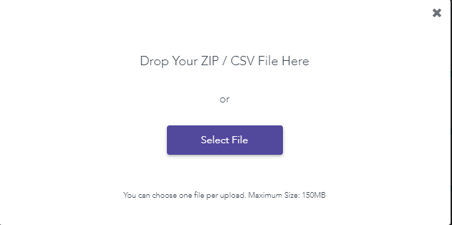

**Test Suite 3: Pixyle - Automatic Tagging – Upload Collection**

AT_UAT 3.1: Upload Collection - ZIP / CSV File

|  |  |  |
| --- | --- | --- |
| Description | This test case covers login with valid credentials, taken to the dashboard and upload a collection scenario. | |
| Link to User Story | PIXYLE_AT_US.pdf 9-16/53 | |
| Assigned To | **Andreja Misevski** | |
| State | Done | |
| Priority | High | |
| Risk | High | |
| Status | PASS | |
| Product | Pixyle | |
| Type | Regression | |
| Automation | **Automated** | |
| Configuration | Windows 10 | |
| Prerequisites | Chrome Version 80.0.3987.116 (Official Build) (64-bit) | |
| Action | | **Expected Result** |
| Login with valid credentials provided from Pixyle | | After logging in, you will be taken to this dashboard where you can see all your uploaded collections and **upload a collection**. |
| Click on Upload Collection | | Pop up dialog appears:   * Drop Your ZIP / CSV File Here or * Select File   Message on the bottom: “You can choose one file per upload. Maximum Size: 150MB” |
| Close the dialog box | | Pop up dialog disappears |
| Expand the list menu at the upper right side | | Upload Collection list item should appear |
| Select Upload Collection | | Pop up dialog appears:   * Drop Your ZIP / CSV File Here or * Select File   Message on the bottom: “You can choose one file per upload. Maximum Size: 150MB” |
| Navigate anywhere in the app | | Verify that the User is able to Upload a Collection using both ways. |

­ AT_UAT 3.2: Attaching

|  |  |  |
| --- | --- | --- |
| Description | This test case covers - after selecting the file to upload, the API is attaching and reading the file (progress bar) | |
| Link to User Story | PIXYLE_AT_US.pdf 9-16/53 | |
| Assigned To | **Andreja Misevski** | |
| State | Done | |
| Priority | High | |
| Risk | High | |
| Status | PASS | |
| Product | Pixyle | |
| Type | Regression | |
| Automation | **Automated** | |
| Configuration | Windows 10 | |
| Prerequisites | Chrome Version 80.0.3987.116 (Official Build) (64-bit) | |
| Action | | **Expected Result** |
| Login with valid credentials provided from Pixyle | | After logging in, you will be taken to this dashboard where you can see all your uploaded collections and **upload a collection**. |
| Click on Upload Collection | | Pop up dialog appears:   * Drop Your ZIP / CSV File Here or * Select File   Message on the bottom: “You can choose one file per upload. Maximum Size: 150MB” |
| Upload file (ex. QA_Collection) | | “We are attaching your collection” and/or “We are downloading your images” message appears and a progress bar. |
| Wait for 5mins maximum for upload to end. | | Verify that the User is taken back to Dashboard and have a progress bar that shows how far the upload of the images has gone. |
| If Connection is lost  Select OK | | “Upload not successfull, please try again” dialog box appears. |
| Establish connection and Reload page | | “Tagging not started!” - Text appears under Tagged products. Refresh icon is available = xPath  //p[.='QA_collection']/../../..//i[@class='redo icon'] |
| Click Refresh icon and If Connection is lost | |  |
| Reestablish connection and Reload page | | Green progress bar appears for verifies that the products have been uploaded and tagged. |

­ AT_UAT 3.3 Upload Error – Re-Upload

|  |  |  |
| --- | --- | --- |
| Description | This test script covers Re-Upload options when and upload error occurs. | |
| Link to User Story | PIXYLE_AT_US.pdf 13-16/53 | |
| Assigned To | **Andreja Misevski** | |
| State | Done | |
| Priority | High | |
| Risk | High | |
| Status | PASS | |
| Product | Pixyle | |
| Type | Regression | |
| Automation | **NO** | |
| Configuration | Windows 10 | |
| Prerequisites | Chrome Version 80.0.3987.116 (Official Build) (64-bit) | |
| Action | | **Expected Result** |
| Login with valid credentials provided from Pixyle | | After logging in, you will be taken to this dashboard where you can see all your uploaded collections and **upload a collection**. |
| Click on Upload Collection | | Pop up dialog appears:   * Drop Your ZIP / CSV File Here or * Select File   Message on the bottom: “You can choose one file per upload. Maximum Size: 150MB” |
| Upload file (ex. QA_Collection) | | “We are attaching your collection” and/or “We are downloading your images” message appears and a progress bar. |
| Force Upload Error!!! UNABLE TO DO? | | Dialog box should appear that contains a list with images that might have errors.  Proceed “AutoTagging” and “Re-Upload Changed File” buttons are available |
| Click the “Re-Upload Changed File” button | | Window browser from my PC immediately opens. |
| Select the file and attach. | | API is attaching and reading file and after the process is finished, the User is taken back to the Dashboard and can see a progress bar that shows how far the re-upload has gone. |
| Re-uploads ends | | The progress bar shows that the upload is over and completed successfully.  Automatic tagging starts immediately afterwards. |
| Tagging ends | | The progress bar shows that the process is done and the User can start verifying images. |

AT_UAT 3.4 Tagging

|  |  |  |
| --- | --- | --- |
| Description | This test script covers a scenario where the Upload and/or Tagging Fails. Re-establishing connection and verify that the User can continue with the process of verifying images. | |
| Link to User Story | PIXYLE_AT_US.pdf 19-22/53 | |
| Assigned To | **Andreja Misevski** | |
| State | **Done** | |
| Priority | High | |
| Risk | High | |
| Status | PASS | |
| Product | Pixyle | |
| Type | Regression | |
| Automation | **NO** | |
| Configuration | Windows 10 | |
| Prerequisites | Chrome Version 80.0.3987.116 (Official Build) (64-bit) | |
| Action | | **Expected Result** |
| Login with valid credentials provided from Pixyle | | After logging in, you will be taken to this dashboard where you can see all your uploaded collections and **upload a collection**. |
| Click on Upload Collection | | Pop up dialog appears:   * Drop Your ZIP / CSV File Here or * Select File   Message on the bottom: “You can choose one file per upload. Maximum Size: 150MB” |
| Upload file (ex. QA_Collection) and once click on the side of the app so the dialog box disappears and the Dashboard can be seen. | | API is attaching and reading file. |
| Disconnect  Upload Fail  Tagging Fail | | Yellow tooltip should be visible. Mouse hover over the button shows the status and refresh can be done.  Tagging not started! Text is shown - Refresh icon is also available. |
| Re-establish connection and Reload the page | | Uploaded products progress bar is green and Tagging not started! text is shown - Refresh icon is still available |
| Refresh tagging | | Progress does not appear until page refresh!!! The tagging of your products is in progress... Please wait untill it's done |

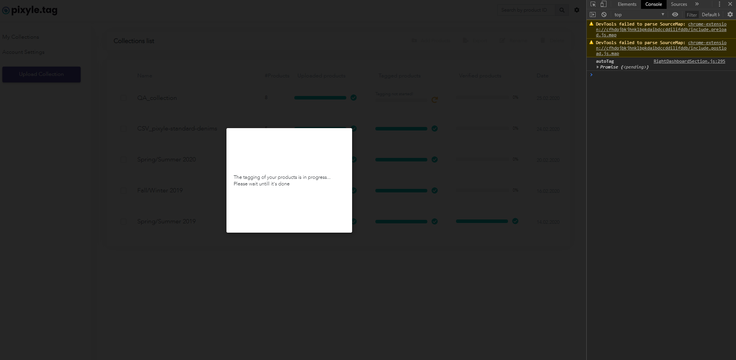

AT_UAT 3.5 Export Collection

|  |  |  |
| --- | --- | --- |
| Description | This test script covers exporting a collection to a json or csv file | |
| Link to User Story | PIXYLE_AT_US.pdf 9-16/53 | |
| Assigned To | **Andreja Misevski** | |
| State | Done | |
| Priority | High | |
| Risk | High | |
| Status | PASS | |
| Product | Pixyle | |
| Type | Regression | |
| Automation | **Automated** | |
| Configuration | Windows 10 | |
| Prerequisites | Chrome Version 80.0.3987.116 (Official Build) (64-bit) | |
| Action | | **Expected Result** |
| Login with valid credentials provided from Pixyle and navigate to Collections (select corresponding one) | | Collection has been selected (checked) and the Export button is available. |
|  | |  |
|  | |  |
|  | |  |

AT_UAT 3.6 Rename Collection

|  |  |  |
| --- | --- | --- |
| Description | This test script covers renaming a collection. | |
| Link to User Story | PIXYLE_AT_US.pdf 26/53 | |
| Assigned To | **Andreja Misevski** | |
| State | Done | |
| Priority | High | |
| Risk | High | |
| Status | PASS | |
| Product | Pixyle | |
| Type | Regression | |
| Automation | **Automated** | |
| Configuration | Windows 10 | |
| Prerequisites | Chrome Version 80.0.3987.116 (Official Build) (64-bit) | |
| Action | | **Expected Result** |
| Login with valid credentials provided from Pixyle and navigate to Collections (select corresponding one) | | Collection has been selected (checked) and the Export button is available. |
|  | |  |
|  | |  |
|  | |  |

AT_UAT 3.7 Add Products – End To End

|  |  |  |
| --- | --- | --- |
| Description | This test script covers a scenario that adds products (Uploading and Tagging - reuse AT_UAT 3.1 and AT_UAT 3.2: Attaching). End To End scenario including delete of the uploaded collection. | |
| Link to User Story | PIXYLE_AT_US.pdf 27/53 | |
| Assigned To | **Andreja Misevski** | |
| State | Done | |
| Priority | High | |
| Risk | High | |
| Status | PASS | |
| Product | Pixyle | |
| Type | Regression | |
| Automation | **Automated** | |
| Configuration | Windows 10 | |
| Prerequisites | Chrome Version 80.0.3987.116 (Official Build) (64-bit) | |
| Action | | **Expected Result** |
| Login with valid credentials provided from Pixyle and navigate to Collections (select corresponding one) | | Collection has been selected (checked) and the Export button is available. |
|  | |  |
|  | |  |
|  | |  |

AT_UAT 3.8 Search by Product ID

|  |  |  |
| --- | --- | --- |
| Description | This test script covers testing search of the application by Product ID. | |
| Link to User Story | PIXYLE_AT_US.pdf 27/53 | |
| Assigned To | **Andreja Misevski** | |
| State | Done | |
| Priority | High | |
| Risk | High | |
| Status | PASS | |
| Product | Pixyle | |
| Type | Regression | |
| Automation | **Automated** | |
| Configuration | Windows 10 | |
| Prerequisites | Chrome Version 80.0.3987.116 (Official Build) (64-bit) | |
| Action | | **Expected Result** |
| Login with valid credentials provided from Pixyle and navigate to Collections (select corresponding one) | | Collection has been selected (checked) and the Export button is available. |
|  | |  |
|  | |  |
|  | |  |